How we work – the “Cut & Paste paradigm”
R-code is “picky” one out of place character and BANG! – the stuff quits working. If you are like me, you can’t remember all the details of the commands you need to give anyway. So I simply have a toolbox full of working examples. I put an example open next to the project I am working on and proceed to toggle between the two cutting and pasting. You typically need to change variable names and titles and run frequent code block tests.
As you continue you should build an expanding set of tool-box-tools. One thing to consider is how to organize your tools. You need to do it in such a way, to make it easy for you to find, when you encounter a future problem that calls for it. One method I have used for datacamp courses is showcased in – link to dataviz.

Here I have a project in AVC_Instructors space called RV 144 Aides Trial
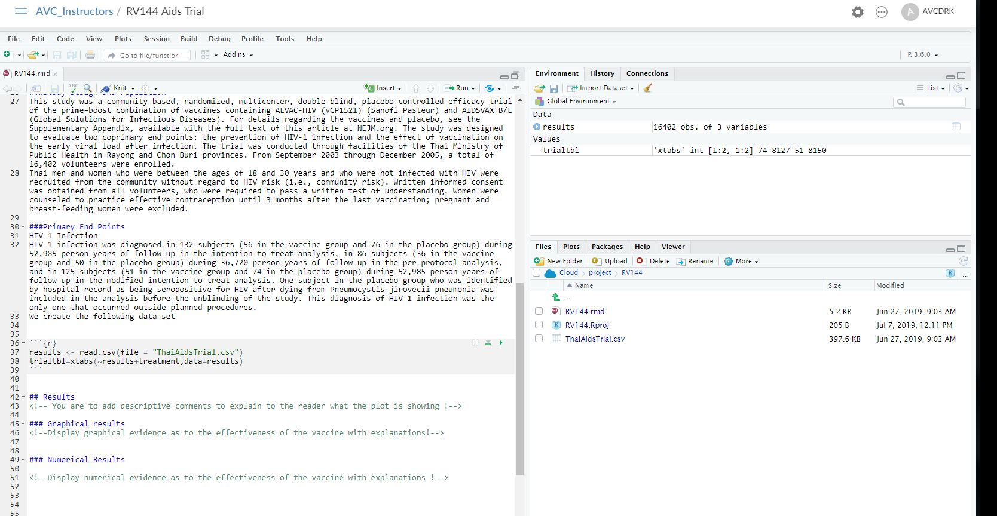
Taking a closer look at our data we have two categorical data variables (factors) in treatment and results
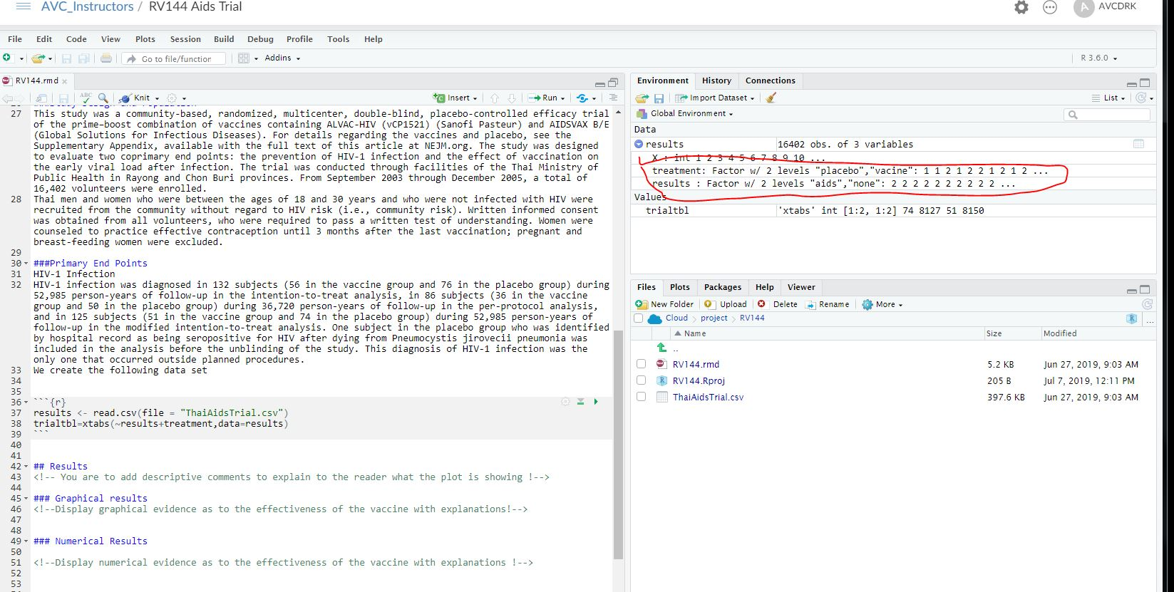

A quick variable analysis says I need to have some cat~cat examples availiable so we look at what is available in our
RMD template project on our USB stick
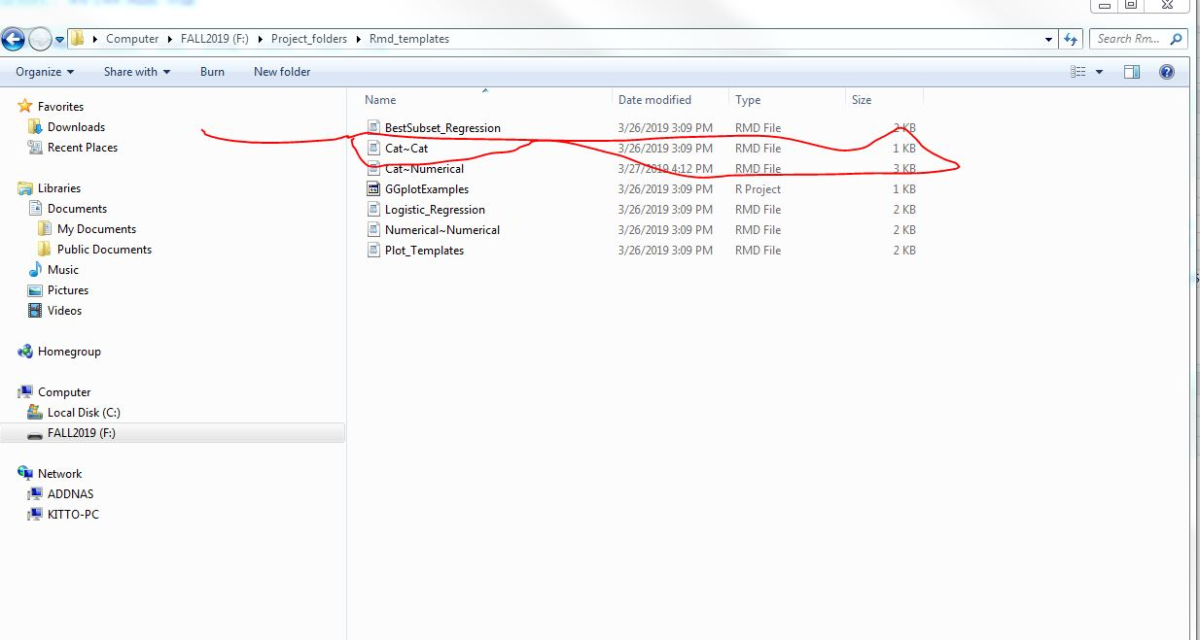

Now we highlite
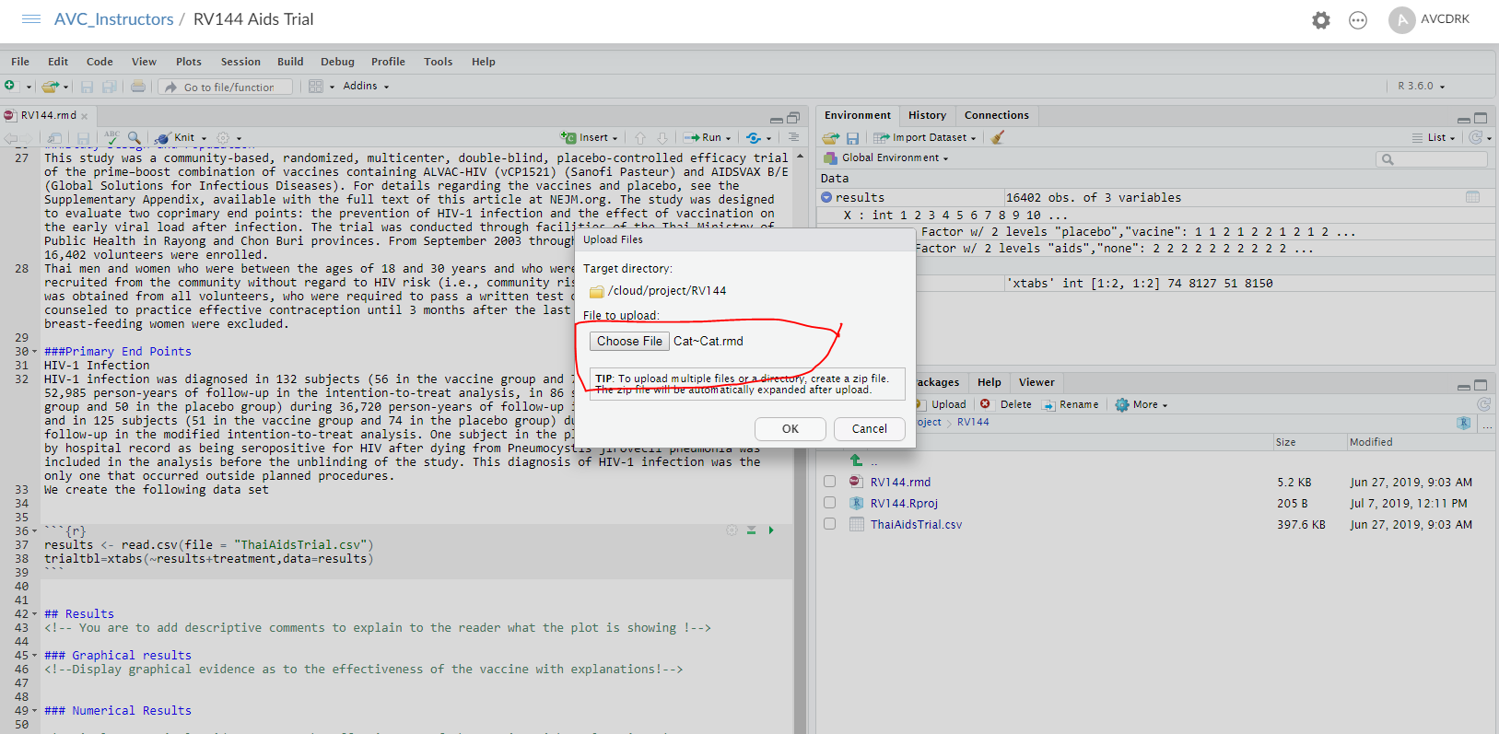

Then hit OK

And we get our file in there

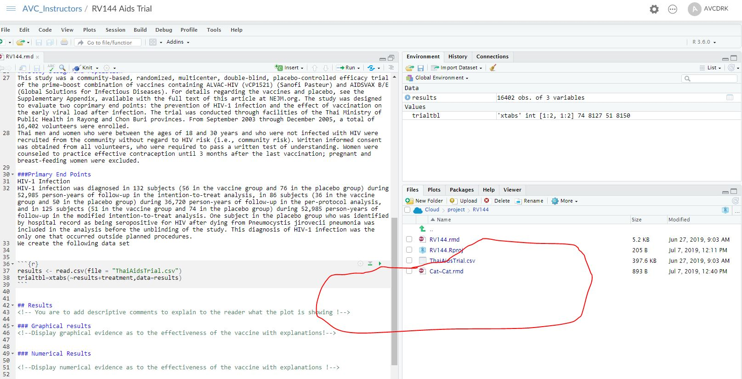
Now we clik on the cat~cat file and have two markdown files open
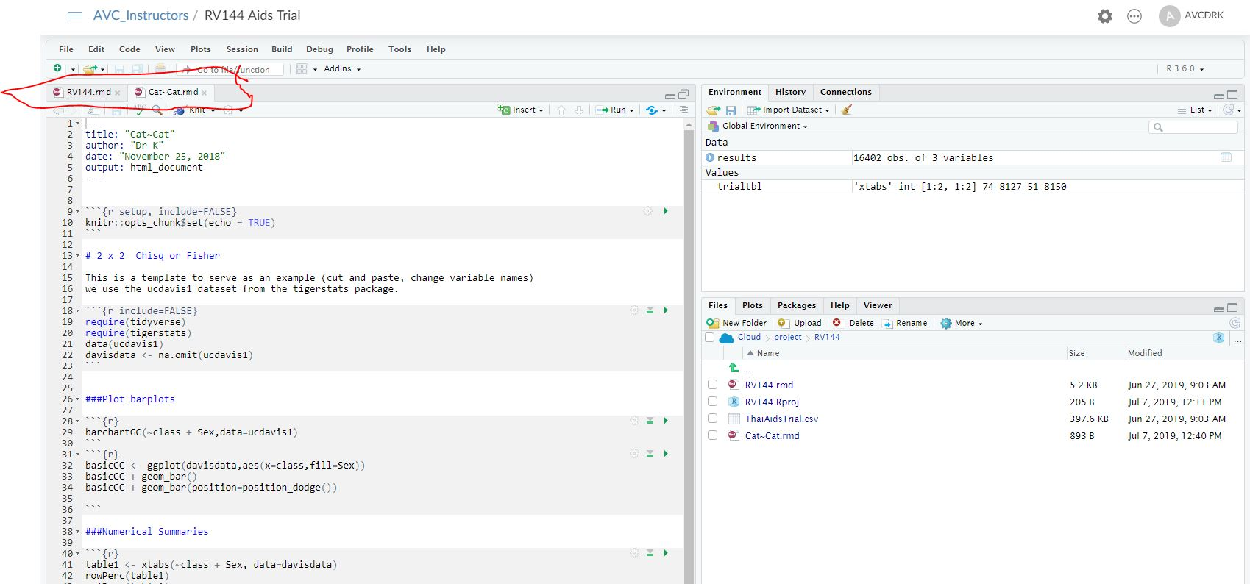
Now we cut and paste the code for barplots, numerical summaries, and inferential test to the RV144 file
Note that the names are incorrect and need editing
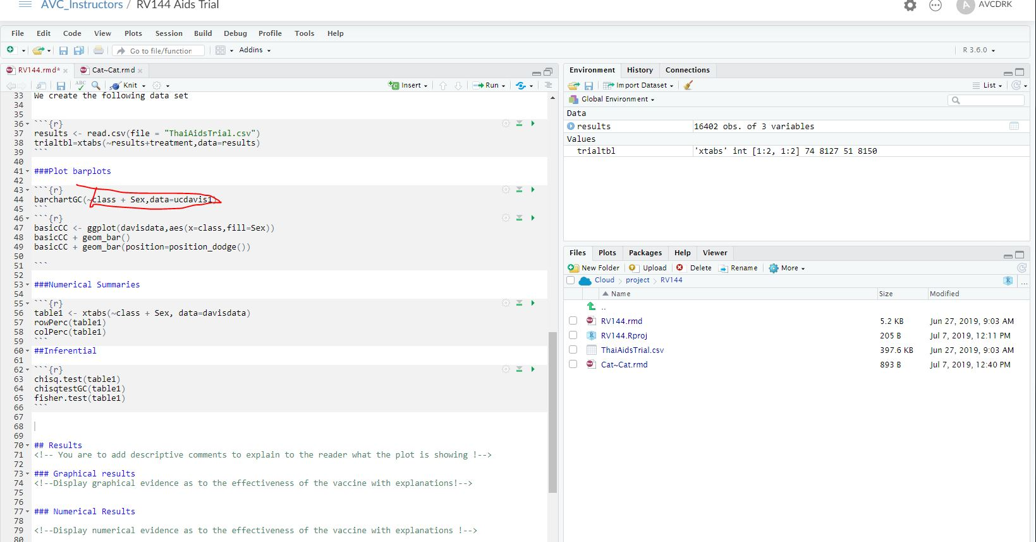
Now we edit the names of our variables etc
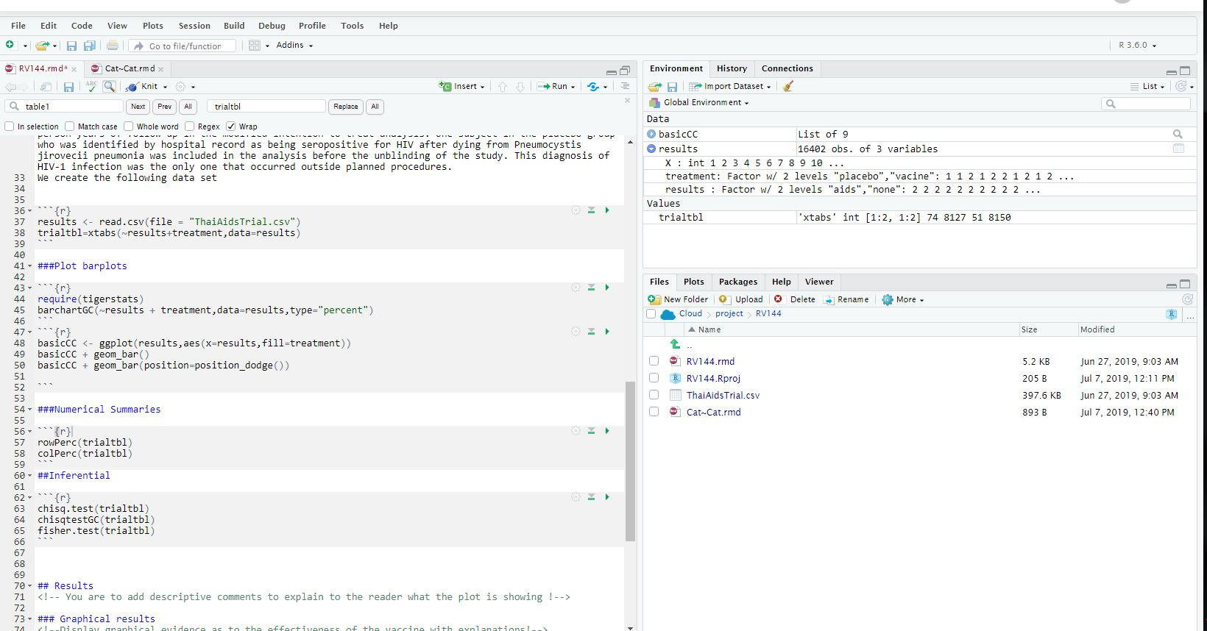
At this point most of our work is done

